**Report**

1. **Application description**

Project contains data base of grocery items communicating through Restlet service with android application which allows: create, edit or delete records from local database.

Main screen of the application is displaying three buttons leading to different store locations.

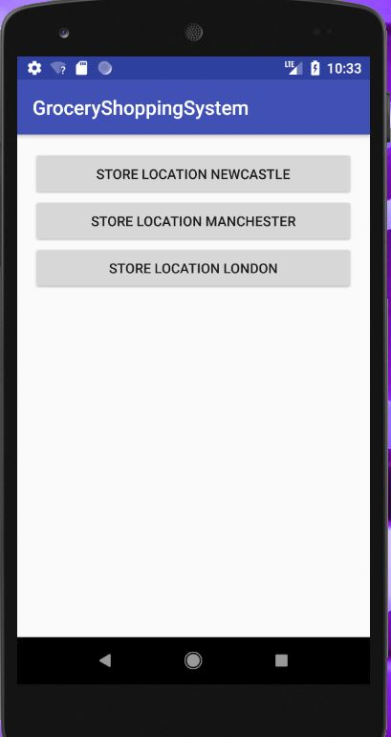

Fig.1

Fig.1 After clicking each button the individual store information is displayed including groceries currently being available in the store and store location address . All information that being displayed on the screen are retrieved by Restful server and pass to the android app.

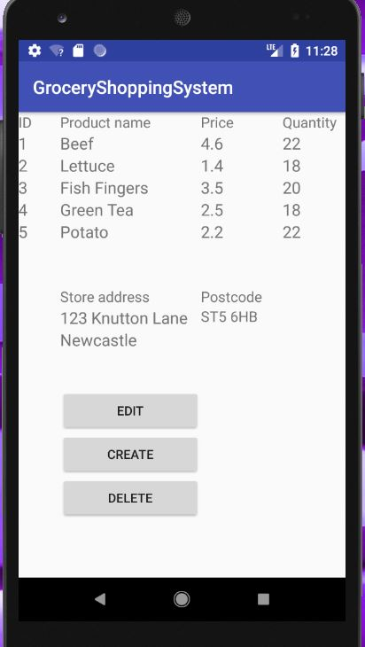

Fig.2

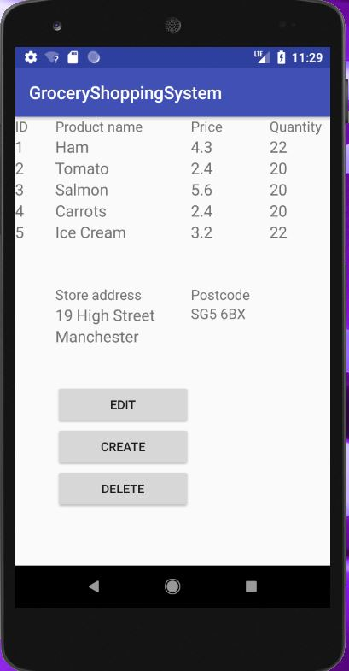

Fig.3

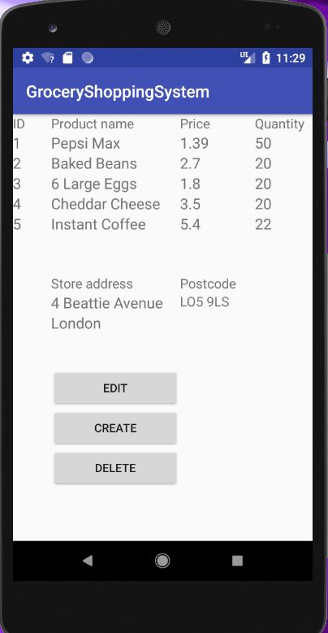

Fig.4

Fig.2,3,4 Below are three buttons which leads to the forms allowing editing, creating or deleting records in database through Restful server.

Fig.5 Edit form.

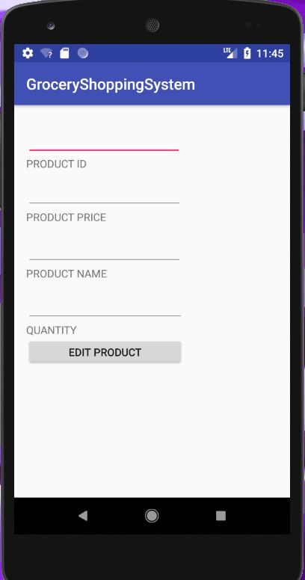

Fig.5

Fig.6 Create form.

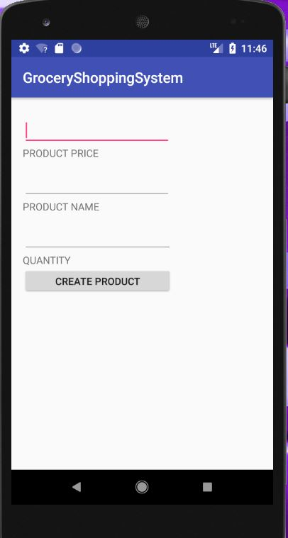

Fig.6

Fig.7 Delete form.

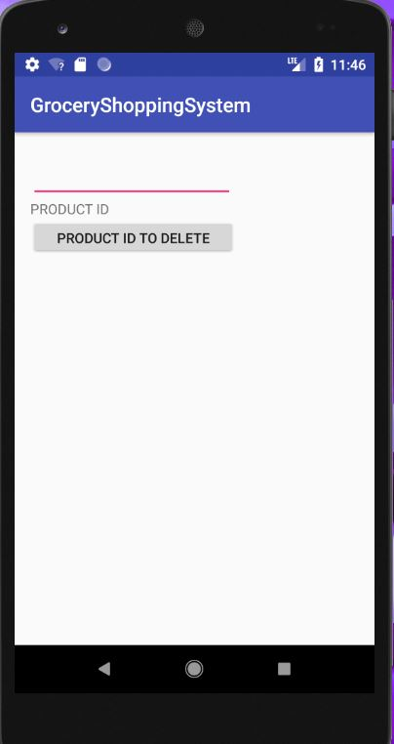

Fig.7

**Application of rubric criterion.**

* Effectiveness and extensiveness of App. The screens layout of my application implements Linear Layout in some screens multiple Linear Layout. I found this layout to be more functional and easier to implement instead of Constraint Layout. My app contains 13 activities and 13 layouts which gives an excellent range of functionality in terms of navigation and functions clarity. As indicated in Fig.8

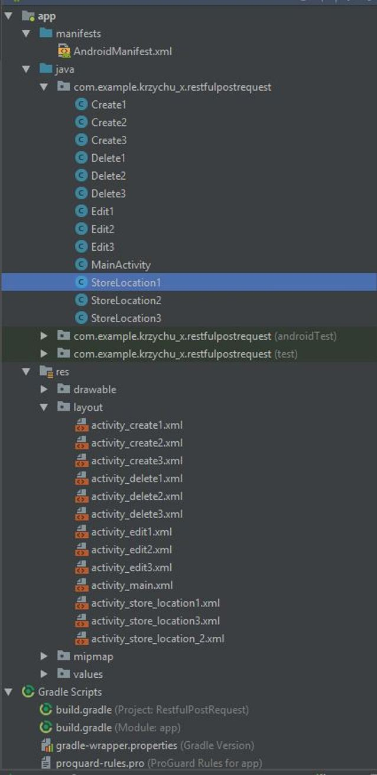

Fig.8

* Code structure, OO principles and error handling. Structure of my code is based on 13 activates which contains appropriate methods . To develop my system I have used Volley library instead of AsyncTask method for managing threads of all my requests with in Restful Server. Volley Library is a more efficient way of managing threads because it stores received requests in cache memory instead of repeats connection many times like in case of AsyncTask method. For example screen position changed by the application. Volley library contains also useful error handling methods and server response receiving methods which have been applied in my application.
* Creating and connecting to a web service. Demonstration of editing record in a database.

Fig.9 Screen indicates retrieved data before editing.



Fig. 9

Fig.10 Screen indicates retrieved data after editing.

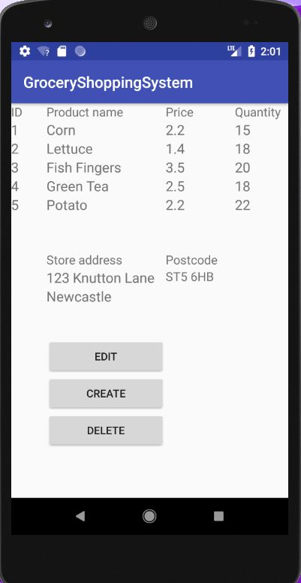

Fig.10

Fig.11 code for putting data into Restful Server.

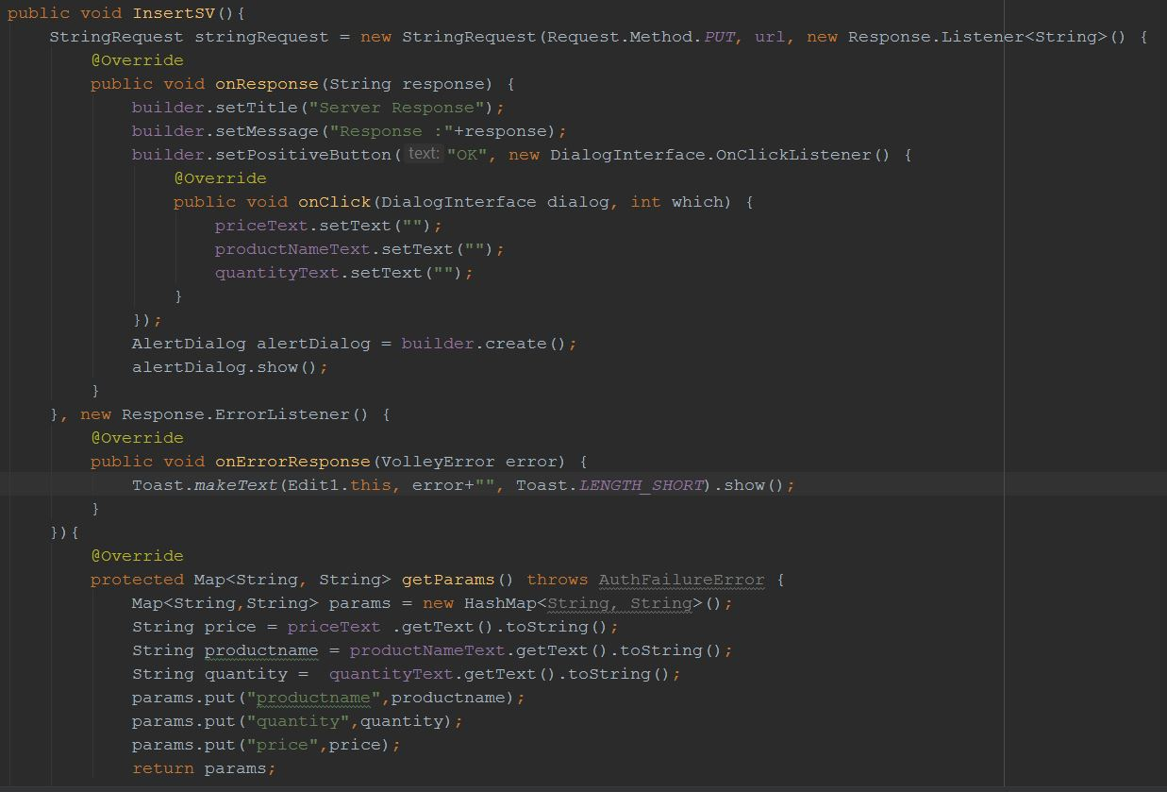

Figure.12 Screen below indicates code used to getting data from Restful server for product and store information.

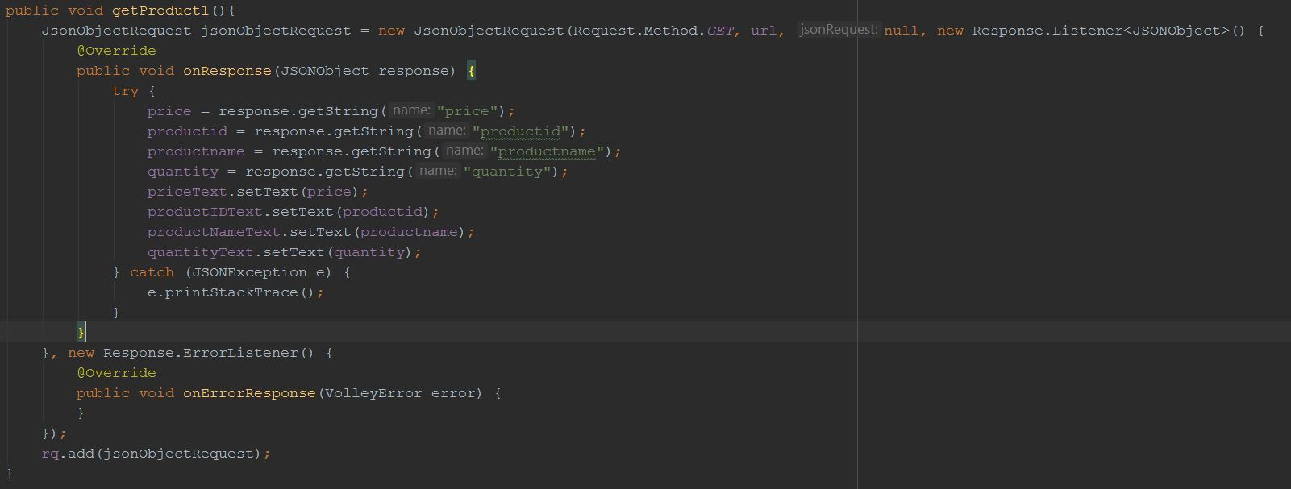

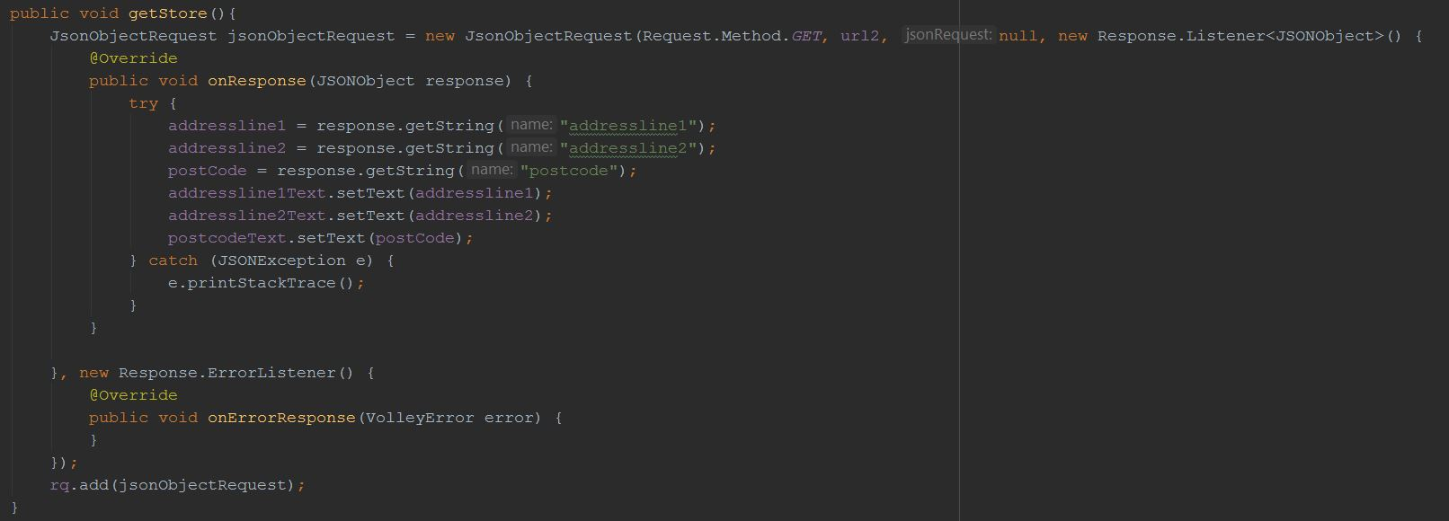

Fig.13 Screen showing deleting product record from data base.

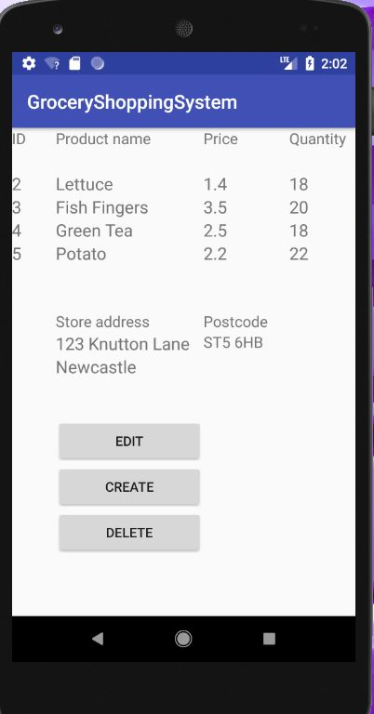

Fig.13

Fig. 14 Screen showing code used for deletion.

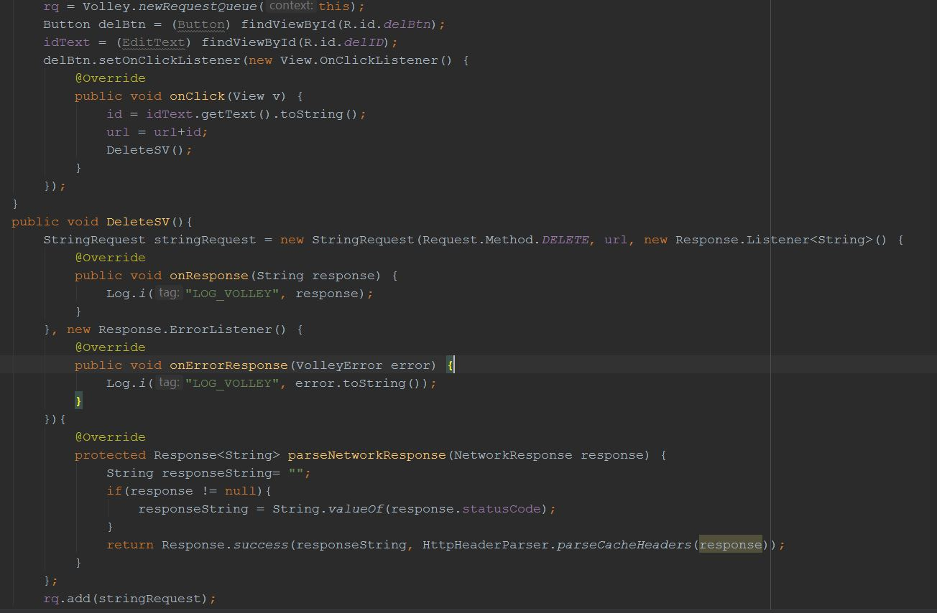

Fig.14

Screen showing retrieved records after creating new product in data base.

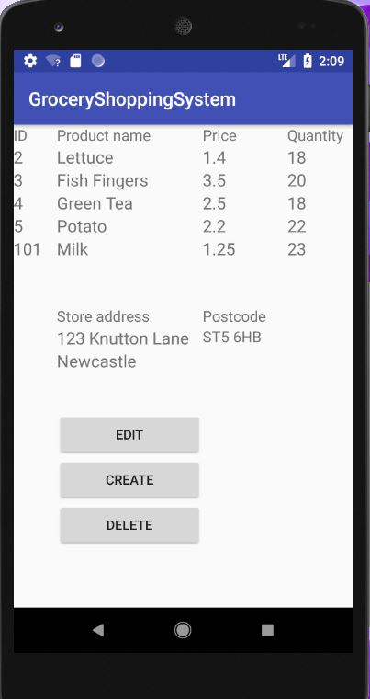

Fig.14

Fig.15 Screen showing code used for creating new product.

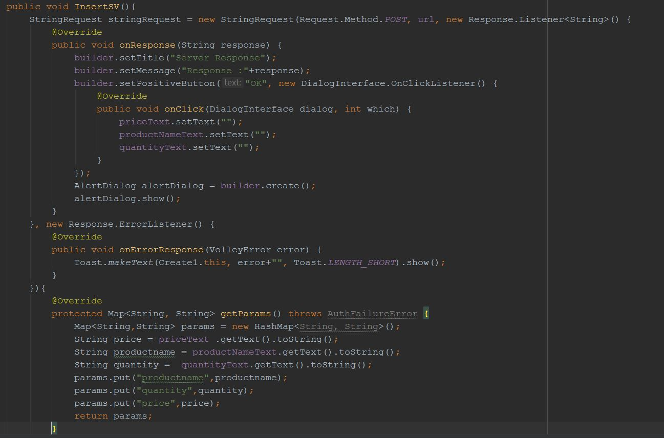

Fig.15

Rubric criteria evaluation:

* Effectiveness and extensiveness of App. I was able to implement more than 4  screens and layouts

, the range of functionality and good use of menus.

•         Code structure, OO principles and error handling. I was able to demonstrate excellent code structure with various activities properly described. Another advantage of my code is reliable errors handling and server responses handling, therefore according to rubric.

•         Creating and connecting to a web service. I was able to implement Volley library with a full range of methods communicating with web service therefore according to rubric requirements

•         Report describing and critically appraising the implementation. I have described in details my application and I have submitted a screenshot for each possible navigation option and screenshot including code for each connection with a Restful server.

**3. Discussion.**

I have found easy to design my application to reflect the model described in Groceries Shopping Application scenario in android. Android Studio is providing a wide range of tools to create navigation through app simple and intuitive therefore it was a less challenging task.

I have found difficult to manage main XML layout displaying products and store location from the database due to a large number of text fields to display in one column. I was able to overcome difficulties by implementing four lanyard layouts as four columns each for one product variable retrieved. This solution gave me expected functionality and flexibility for my screen.

Another problem I have encountered was establishing a connection between the Restful server and android application. I have overcome this problem by simply performing an extensive range of methodical testing and applying different code variations plus researching wide scope of recourses. This approach eventually helped me to find a proper solution.

If I would perform similar project again I would improve the way JSON data is retrieved from the Restful server. I would store data in JsonArray request rather than JsonObject requests.This, in turn, would improve both design structure and code functionality.

Moreover, by improving server request would also help to implement viewList instead of textView which in fact, would have been a better solution for displaying retrieved data.

The project could be extended for further implementations like login system allowing register users or basket implementation for shopping possibility.